TITLE OF PAPER (style heading 1: font formats - times new roman, 12 pt bold, ALL CAPS; paragraph formats: centered, spacing before 30 pt, spacing after 0 pt, keep with next, KEEP LINES TOGETHER)
UDC (12pt italic, centered, spacing before 6 pt, spacing after 30 pt,
keep with next)

Authors
(Style Heading 2: 10 pt bold, title case, centered, spacing before 0 pt, spacing after 12 pt, keep with next, keep lines together)
Affiliation (Style Affiliation: 10 pt, centered, spacing before 0 pt, after 18 pt, keep with next)
Abstract (bold). Short abstract (Style Abstract: 9 pt, italic, justified, 0.75 cm left and right indentation).
Key words (bold): key word 1, key word 2... to (max) key word 6
JEL Classification (bold): (9pt, separated by commas, justified, 0.75 cm left and right indentation, spacing before 18 pt, after 0 pt, keep with next). Please indicate appropriate JEL classification codes (https://www.aeaweb.org/econlit/jelCodes.php)

1. Main heading (Style Heading 3: small caps 10 pt, centered, spacing before 24 pt, spacing after 6 pt, keep with next, keep lines together)
Main text: only use characters and symbols available in the Times New Roman or Symbol font (as in the full text of paper), 10 pt; paragraph format: justified alignment, left and right indent 0 pt, space before and after 0 pt, first line indent 0.5 cm.

1.1. Subheading (Style Heading 4: 10 pt, bold, left, indentation left 5 pt,
spacing before 12 pt, after 6 pt, keep with next, keep lines together)
Sample of main text. Sample of main text. Sample of main text. Sample of main text. Sample of main text. Sample of main text. Sample of main text. Sample of main text. Sample of main text. Sample of main text. Sample of main text. Sample of main text. Sample of main text. Sample of main text. Sample of main text. Sample of main text. Sample of main text. Sample of main text. Sample of main text. Sample of main text. Sample of main text. Sample of main text. Sample of main text. Sample of main text.

1.1.1. Subheading of the 3nd level (Style Heading 5: 10 pt, italic, left, indentation left 5 pt, spacing before 12 pt, after 6pt, keep with next, keep lines together)
Sample of main text. Sample of main text. Sample of main text. Sample of main text. Sample of main text. Sample of main text. Sample of main text. Sample of main text. Sample of main text. Sample of main text. Sample of main text. Sample of main text.
Equations should be prepared using Equation Editor as a part of MS Word, with styles and sizes as defined (see Fig. 1). Equations should be typewritten using MathType add-on (http://www.mathtype.com). For equations in your paper (Insert | Object | Create New | or MathType Equation), and, with the number, placed in parentheses at the right margin. Reference to equations should use the form "Eq. (2)" or simply (2). Each formula should occupy one line.
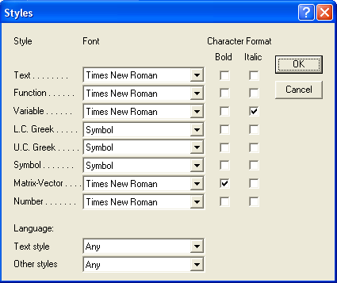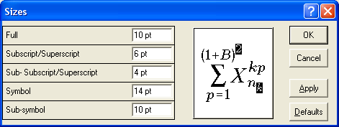
Fig. 1 Title of figure
$h_{\text{ci}}=\frac{q}{S(T_{\text{wi}}−T_{b})}$ (1)
Paragraph format for equations are (Style Equation): left indentation, 6 pt before and after, equation is at position of centered tab at 6.25 cm, number of equation is at position of right tab at 12.7 cm.

Illustrations: figures, photographs, line drawings, graphs
(Styles Figure and Figure Title)
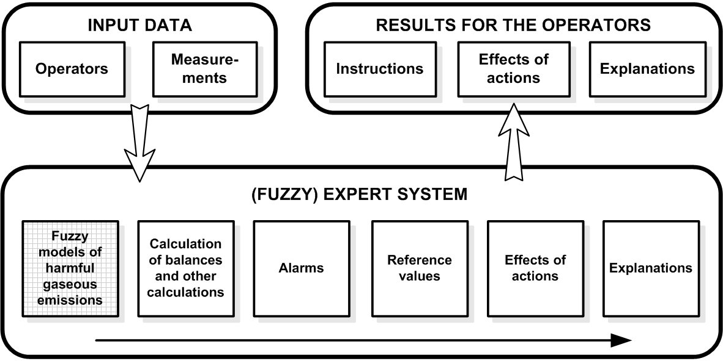
Fig. 2 Title of figure
Source: xxxxxx
All illustrations (figures, photographs, line drawings, graphs) should be numbered in series with consecutive Arabic numbers and all legends should be included at the bottom of each illustration. All figures, photographs, line drawings and graphs, prepared in electronic form, should be converted in TIFF or JPG (max quality) files, in 300 dpi resolution, for superior reproduction. Figures, line drawings and graphs prepared using elements of MS Drawing or MS Graph must be converted in form of pictures and unchangeable. All illustrations should be planned in advance so as to allow reduction to 12.75 cm in column width. Please review all illustrations to ensure that they are readable.

Tables
Table 1 Title of table (Style Table title)
System | Symbol
Without delay | +
Delay h = 1 | −
Delay h = N = 34 | *
Source: xxxxx
All tables should be numbered with consecutive Arabic numbers. They should have descriptive captions at the top of each table and should be mentioned in the text.
Acknowledgement: The paper is a part of the research done within the project 1234567890. The authors would like to thank to the... (Style Acknowledgement).
Note: Citation in the text
The APA style citation and referencing is applied in the journal (according to the instructions that can be downloaded from the link http://www.apastyle.org/).
Citations in the text should be given in brackets, stating the author's surname, year of publication and, possibly, pages, if it is a direct quote):
- in the case of summary or paraphrase, references should appear in brackets with the author's name, followed by the year (Haller, 2015), or (Smith & White, 2001) or in the case of multiple authors (Beckman et al., 2007);
- if the author is not known, give the title of the work and the year (Climate Change, 2009);
- if the same author has published more than two papers at the same year, then the papers are alphabetically separated, i.e. (Hall, 1990a; 1990b);
- in the case of quotation, add the page number, i.e. (Smith, 2001, p. 10);
- if the reference is within the body of the clause, give the author’s name and only the year of the paper in brackets, i.e. In Smith (2001) it is proposed …

References
References should follow the APA Style convention, in alphabetical order at the end of the paper. If a referenced paper has multiple authors, they all should be quoted.

The list of references should be formatted so that the second row in each entry is indented (Paragraph Indentation, Special - choose Hanging, by 0.5cm).

Wherever possible, provide the DOI number, too, in addition to other reference data.

Please, check the examples:

Book with the named authors:
Model: Surname, name initial (s). (year of publication). Book title. Place of publication: Name of publisher.
Example:
O'Hara, M. (2004). Market microstructure theory. Cambridge: Blackwell Publishers.
Hair, F. J., Bush, P.B., & Ortinau, D. J. (2006). Marketing research. 3rd edition, New York: McGraw-Hill, Inc.

Book (publication) in which the institution is listed as an author:
Model: Institution (year). Title. Place of publication: Name of publisher.
Example:
OECD (2013). OECD Economic Surveys: China 2013. Paris: OECD Publishing.

Proceedings with the named editors:
Model: Surname, initials. (Eds.) (year). Book title. Place of publication: Name of publisher.
Example:
Bisignano, J. & Hunter, W. (Eds.) (2000). Global financial crises: Lessons from recent events. Boston: Kluwer Academic Publishers.

Paper (section) in the proceedings or other collective publication:
Model: Surname, initials. (year). Section title. In:Surname and initial of the editor (Ed.), Title of the publication (pages). Place of publication: Name of publisher. If the publication has two or more editors, instead of (Ed.) state (Eds.).
Example:
McKinnon, R. (2000). Limiting moral hazard and reducing risk in international capital flows: The choice of an exchange rate regime. In: Bisignano, J. & Hunter, W. (Eds.), Global financial crises: Lessons from recent events (pp. 159-176). Boston: Kluwer Academic Publishers.

Paper in the journal by one author:
Model: Surname, initials of all authors. (year). Paper title. Journal title, volume number (number of issue), pages.
Examples:
Bonabeo, E. (2004). The Perils of the Imitation Age. Harvard Business Review, 82 (6), 45-54.
Frenkel, J. & A. Levich, R. M. (1975). Covered interest arbitrage: Unexploited profits? Journal of Political Economy, 83 (2), 325-338.
Shaw, D. S., Hogg, G., Wilson, E., Shiu, E. & Hassan, L. (2006). Fashion Victim: The Impact of Fair Trade Concerns on Clothing Choice. Journal of Strategic Marketing, 14 (4), 427-440.

Paper still unpublished in the journal (e.g. in press):
Model: Surname, initials. (forthcoming) Paper title. Journal title.
Example:
Marinković, S. & Radović, O. (forthcoming). Bank net interest margin related to risk, ownership and size: An exploratory study of the Serbian banking industry. Economic Research.

Working papers / documents for discussion:
Model: Surname, initials (year). Work title (working paper title, no.). place of publication: Name of publisher.
Example:
Muzio. D, Kirkpatrick, I. & Kipping, M. (2010). Professionalism without Professions: The Case of Management Consultancy in the UK (CERIC Working Paper, 8), Leeds: Leeds University Businsess School.
Note: Please note the difference between these and the documents available on the Internet. Working papers i.e. documents for discussion need not be exclusively available on the Internet, nor even available online. These are periodic publication of certain institutions usually numbered in order.

PhD Thesis
Model: Surname, name initial (s). (year of publication). Dissertation’s title. Ph.D. Thesis. University.
Example:
Holyoak, B. (2006). Matrix Analysis in Predicting Economic Time Series. Ph.D. Thesis. Bournemouth University.

Article in the newspaper with the named author:
Model: Surname, initials (year). Article title. Newspaper title, date.
Example:
Krugman, P. (2011). Killing the Euro. The New York Times, 1 December.

Newspaper article without named author:
Model: Article title (year). Newspaper title, date.
Example:
Siemens to pay € 170m to Greece over alleged bribery of officials (2012). Financial Times, 9 March.

Document or database from the Internet, private or official website:
Model: Surname, initials (year). Work title, Retrieved from: internet source, Accessed on: Date of access.
Example:
Choibamroong, Т. (2010), Knowledge of Tourism Behavior: A Key Success Factor for Managers in Tourism Business, Retrieved from: http://faculty.ksu.edu.sa/73944/DocLib/Consumer%20Behavior%20Models%20and%20Consumer%20Behavior%20in%20Tourism.PDF, Accessed on: 16 April 2009.

Publications published in languages other than English or written non-Latin scripts:
Note: Publication title or paper in other languages should be left in the original language.
If original reference is not in English, the english translation of the title must be placed in square parenthesis after the original title of the source.
Example 1:
Schmidt, G., Allouche, J., Bardelli, P. & Beaujolin-Bellet, R. (2012). Restructurations d'enterprises [Restructuring of Enterprises]. Revue française de gestion, 38 (220), 73-74.
Example 2:
Капелюшников, Р. (2013). Сколъко стоит человеческий капитал России? [Russia's human capital: What is it worth?]. Вопросы Экономики, 2, 24–46.

Indirect sources:
Note: This type of citation is acceptable only if the author is not able to operate under normal perseverance to get to the primary sources. If this is the case, always specify a primary source first, followed by the indirect source placed in parentheses.
Example:
Israel, G. & Ingrao, B. (1990). The invisible hand. Cambridge: MIT Press. (Quoted in: Minsky, P. H. (1995). Financial factors in the economics of capitalism. Journal of Financial Services Research, 9, 197-208).

The title and subtitle:
Note: For some books, rarely with papers in journals, appears the title followed by a subtitle. If justified, the subtitle may also be named separated from the title by a colon, even if such punctuation on the cover or title page is not used. The first word in the subtitle should always be written with a capital letter.
Example:
Harris, L. (2003). Trading and Exchanges: Market microstructure for practitioners, Oxford: Oxford University Press.

NASLOV NA SRPSKOM - TITLE IN SERBIAN
(12pt bold, centered, space before 24pt, 6 pt space after, keep with next)

Abstract in Serbian - Apstrakt na srpskom (9pt, 0,5 cm, special first line 0,5 cm, justified).

Ključne reči: (key words in Serbian)

